LoginScenario_TestForLoginWithNewlyRegisteredUser_Instance1_29-Jun-2017_05-37-26_AM_Register.png

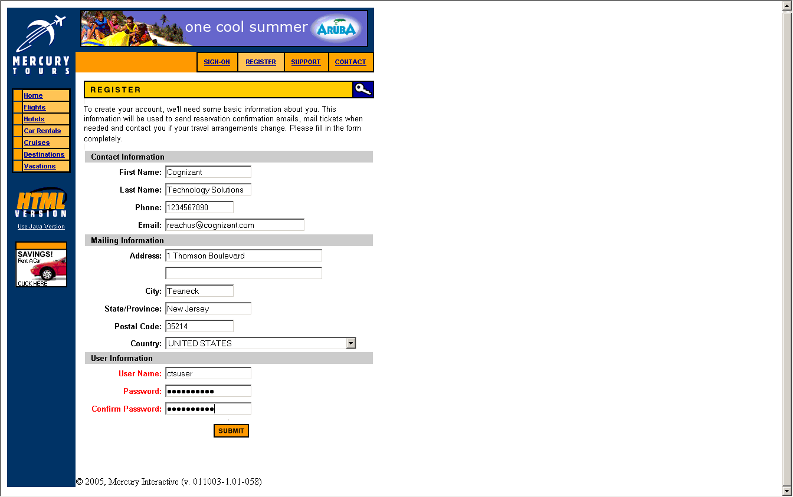

LoginScenario_TestForLoginWithNewlyRegisteredUser_Instance1_29-Jun-2017_05-37-29_AM_Verify_Registration.png

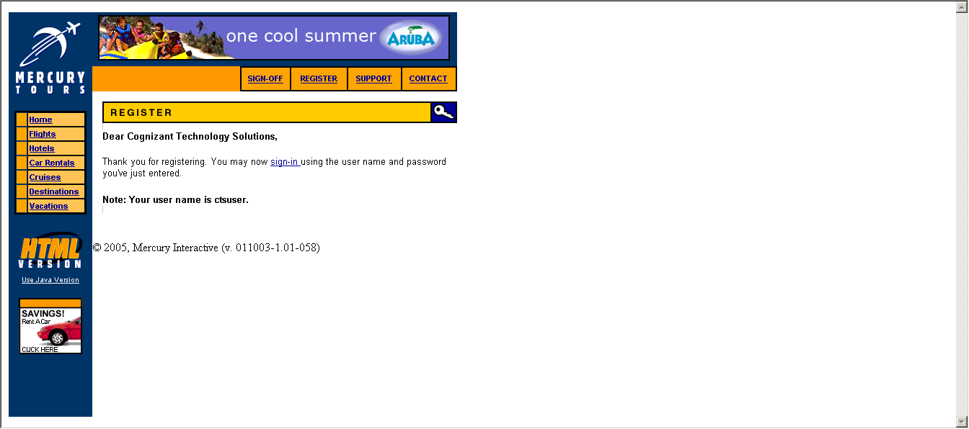

LoginScenario_TestForLoginWithNewlyRegisteredUser_Instance1_29-Jun-2017_05-37-30_AM_Enter_user_credentials.png

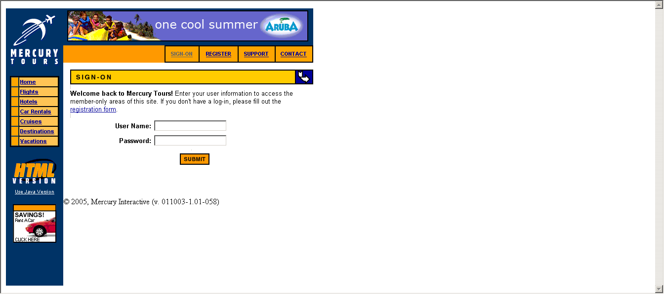

LoginScenario_TestForLoginWithNewlyRegisteredUser_Instance1_29-Jun-2017_05-37-31_AM_Login.png

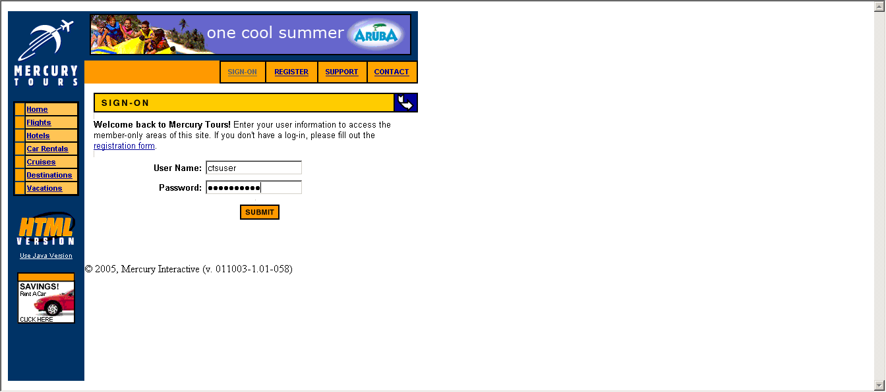

LoginScenario_TestForLoginWithNewlyRegisteredUser_Instance1_29-Jun-2017_05-37-38_AM_Verify_Login.png

